Sound Regulations in Switzerland
From the Live DMA Working Group “Music is no noise! – Sound regulations for live music scenes in Europe” that took place in February 2019.

Inside the venue:
Switzerland has 26 cantons: as many ways to monitor and/or sanction clubs as there are cantons and communes.
Ordinance on the Protection of Audiences from Exposure to Hazardous Sound Levels and Laser Beams: General retrictions for any type of event:
Unamplified sound is not yet subject to any obligation.
Limit value is 100dB(A) average per hour throughout the whole event.
The momentary value must never exceed 125dB (A) at any time.
The Ordinance defines three categories of events:
1. Events that will not exceed 93 dB(A) per hour throughout the whole event. No specific regulation except having a regional permission.
2. Events with an average sound level between 93 dB(A) and 96 dB(A)leq60’
3a. Events with an authorised sound level between 96 dB(A) and 100 dB(A) leq60’
3b)Same category but with a duration of the sound system exceeding three hours

Outside the venue:

Information not provided.

Complementary measures:
1. Events that will not exceed 93 dB(A) per hour throughout the whole event. No specific regulation except having a regional permission.
2. Events with an average sound level between 93 dB(A) and 96 dB(A)leq60’
>> Public must be informed by means of posters about the risks involved
>> Hearing protection devices must be made available free of charge.
>> Noise level must be monitored during the event

3a. Events with an authorised sound level between 96 dB(A) and 100 dB(A) leq60’
>> Same requirements as those in the second category apply
+ an autorisation for a limitation must be requested.
+ the sound system does not last more than three hours.
3b)Same category but with a duration of the sound system exceeding three hours
>> A 85dB per hour compensation zone must be set up
>> Sound level must be record (and keep the measurment during 30days)

Annex:
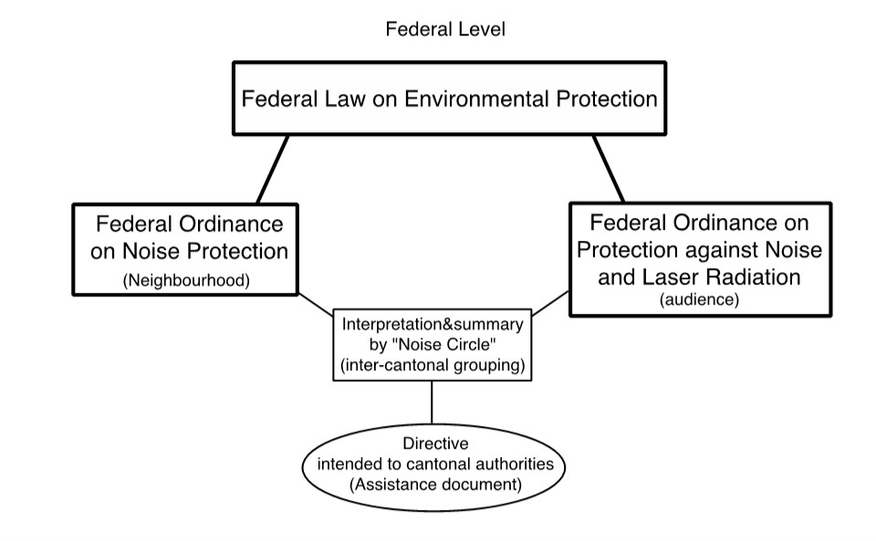

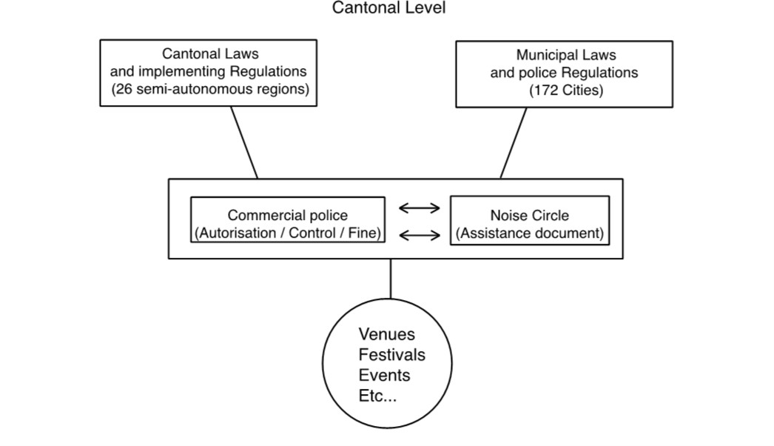Disclaimer: The information used in this document are drawn from the Live DMA Working Group on sound regulations that took place in February 2019. In spite of all the care devoted to the editing of this publication, the publisher cannot accept liability for any damage that is the result of any error in this publication.

