Sound Regulations in the Netherlands
From the Live DMA Working Group “Music is no noise! – Sound regulations for live music scenes in Europe” that took place in February 2019.
Inside the venue:
Prevention of hearing loss for the public:
In December 2018, VNPF, the umbrella association for the Dutch live music sector, signed a new 4-year agreement with the department of health. The rules to prevent hearing loss amongst the public only apply to the VNPF members. One of them is that measured over 15 minutes the music in average may not be louder than 103 dB(A).

Labour conditions (also based on European regulations):
- When exposed to a daily dose above 80 dB (A), the employer must make ear protectors available.
- With daily exposure to a dose above 85 dB (A), employees are obliged to wear hearing protectors.
- A Plan of Approach must be made for exposures above 85 dB (A).
- If the limit of 87 dB (A) is exceeded (measured in the ear, taking into account the hearing protectors), it must be ensured that the noise is brought below this limit value.
- Employers must adequately inform their staff about the dangers of noise.
- Employees are entitled to a hearing test to establish that the measures taken are effective.

Outside the venue:
Environmental law:
It is very complicated. Basically it comes down to this but municipalities make there own rules. In general it is workable. ( + see chart below).

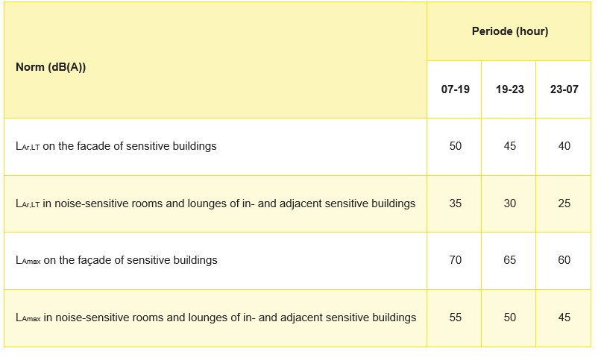

Disclaimer: The information used in this document are drawn from the Live DMA Working Group on sound regulations that took place in February 2019. In spite of all the care devoted to the editing of this publication, the publisher cannot accept liability for any damage that is the result of any error in this publication.

