Sound Regulations in Catalonia (Spain)
From the Live DMA Working Group “Music is no noise! – Sound regulations for live music scenes in Europe” that took place in February 2019.

Inside the venue:
105 db(A)

Outside the venue:
7am to 9pm: 60 db(A) ; 9pm to 11pm: 60 db(A) ; 11pm to 7am: 50 db(A).
/!\ Depends on the "acoustic area" defined by the law (see chart in Annex).

Complementary measures:
Have a sound limiter in each room sealed by the police and connected to the department of environment of the town hall.
Have a sign at the entrance of the room, noting that:
"NOISE LEVEL above 90dB(A). NOISE LEVELS WITHIN THIS PLACE CAN SERIOUSLY INJURE THE EAR"

Annex:

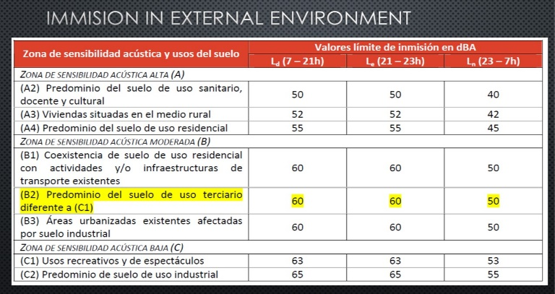

Disclaimer: The information used in this document are drawn from the Live DMA Working Group on sound regulations that took place in February 2019. In spite of all the care devoted to the editing of this publication, the publisher cannot accept liability for any damage that is the result of any error in this publication.

